**Marketing Strategies of TATA**



Submitted To

Dr. Arunkumar Sivakumar

Submitted By

**20BCD7094** RAMPAM GREESHMA GEETHIKA

**20BCD7095** PEDDIBHOTLA SREE RAKSHITHA

**20BCI7025** SANDHYA ESHWARAN

**20BCN7105** DEEPASHREE PRADEEP VAIDEESWAR

**ABSTRACT:**

**1) Introduction**

**1) Background of your study with literature support cited with APA format**

The TATA Group, an Indian multinational company which has it’s headquarters in Mumbai, India established in 1868. It is India’s largest conglomerate, with products and services in almost over 150 countries, and operations in 100 countries across 6 continents. Jamsetji Tata referred to the Father of Indian industry, is the founder of the TATA Group. There are 29 publicly-listed TATA group companies with a combined capitalisation of INR 23.4 trillion as of December 31, 2021. Significant TATA group affiliates include TATA consultancy services, TATA consumer products, TATA motors, TATA power, TATA steel, Voltas, Titan company, Tanishq, TATA chemicals, TATA communications, Trent, TATA Elxsi, Indian hotels company, Air India, TajAir, TATA cliq, TATA capital, Croma and TATA starbucks.

**2) Problem Area**

TATA Group has ventured into a lot of businesses in and outside India. Our project sheds light on the consumer’s perception of TATA. It also contains suggestions as to how TATA can improve their services in order to widen their outreach and sales from a consumer point of view.

**3) Problem Statement (Research Q's and Research Objectives)**

Consumer Satisfaction survey on TATA Group.

**Research Questions:**

1. Do you know anything about TATA Group?
2. Do you like TATA Group in general?
3. Have you used any TATA products, like TATA salt, coffee, motors or electronics (or any other products mentioned in the form description)?
4. Which TATA products have you experienced so far?
5. Rate the TATA products on a scale of 1 to 5.
6. Do you know that 66% of TATA's profit goes to charity?
7. "TATA Group is not just manufacturing products; it is changing the business market of India."

What is your opinion about this statement?

1. How can TATA be more consumer friendly and hence improve their outreach and sales?
2. Do you think that in the next 10-20 years TATA will reach to a level that it can compete with brands like Tesla or any other leading car manufacturing companies in the world?
3. Lastly, if you have anything to say about TATA Group, please feel free to share your thoughts/ opinions here.

**Research Objectives:**

1. To know what percentage of people know in what all businesses TATA has ventured into.
2. To know the general perception of TATA as a national brand.
3. To know what percentage of people prefer TATA over the other brands, i.e how many of them are loyal to the brand.
4. Whether people think TATA motors can become a leading global automobile manufacturer in the forthcoming years.
5. Lastly but not the least, in what ways can TATA improve in order to become more consumer friendly.

**4) Research hypothesis**

**Null hypothesis:** TATA is a well-established brand in India and there is no house in India which has not used any FMCG product of TATA. In general, people have a very good impression on TATA and also the charity work they are doing.

**Alternate hypothesis:** TATA is not a well-established brand among the common people of India.

**2)literature review**

**1) Conceptual review**

**2) Research finding review**

**3) Research gap**

**4) Conceptual Model of research**

**3) Research Methodology**

**1) Types of research design**

**2) The population of the study**

**3) Probability or Non-probability sample**

**4) The sample size of the study**

**5) Questionnaire Development (Content and Face validity)**

**6) Reliability**

**7) Measurement scale used (Nominal scale, likely scale)**

**8) Questionnaire administration (Distribution of Question/survey details)**

**9)Statical tools used (Frequency analysis, ANOVA, Co-relation analysis)**

**4) Findings and analysis (Result tables with interpretation)**

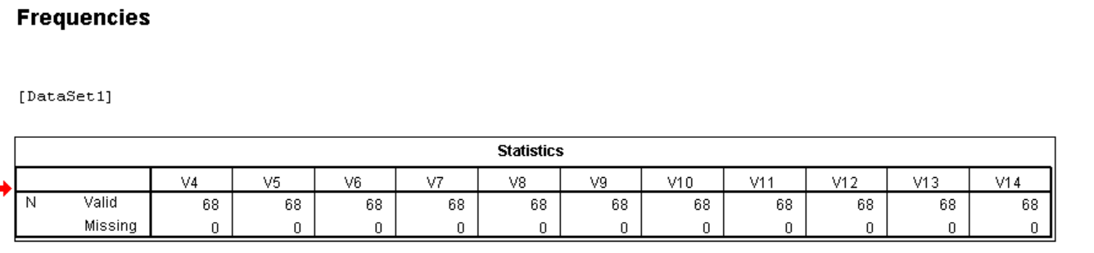 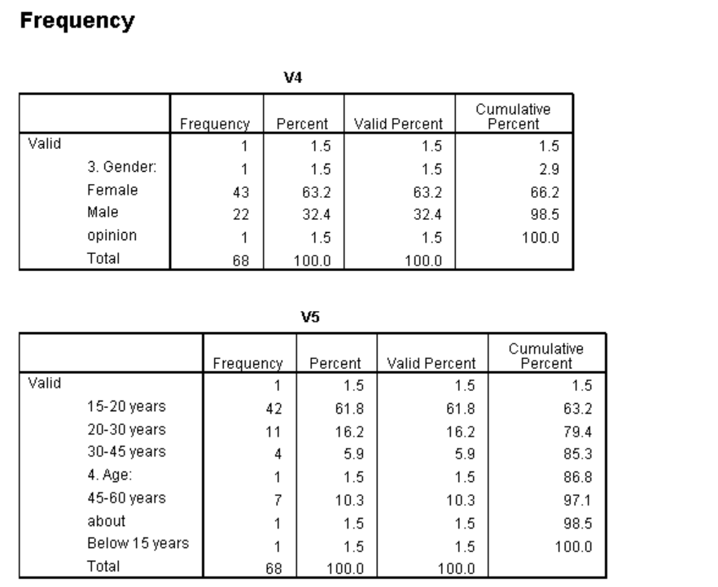 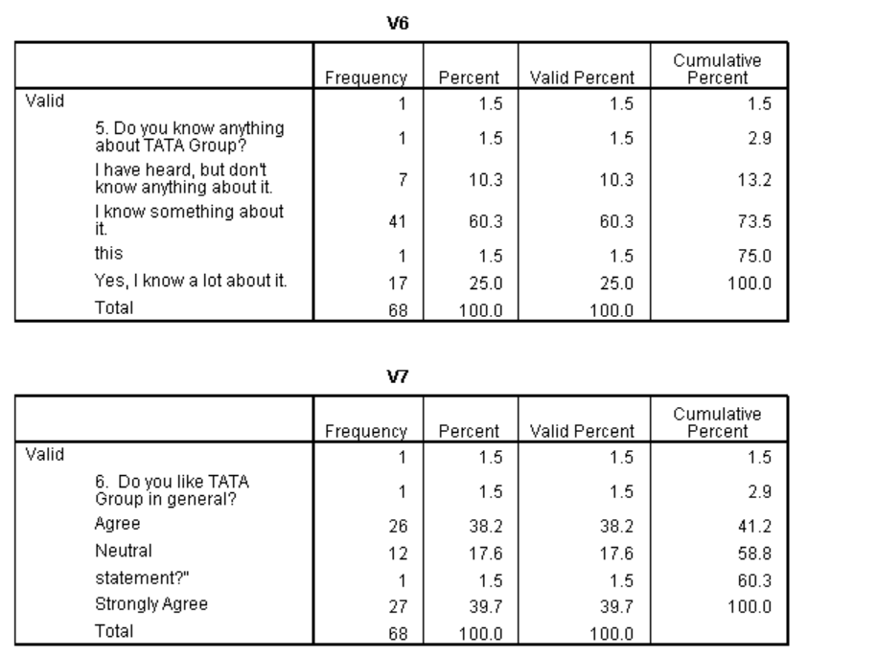 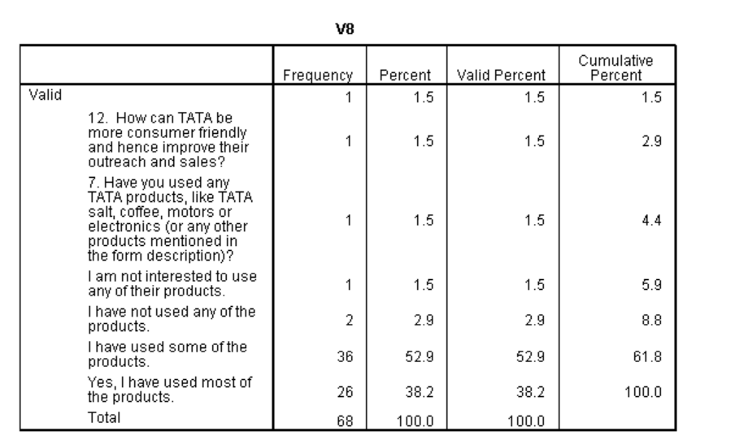

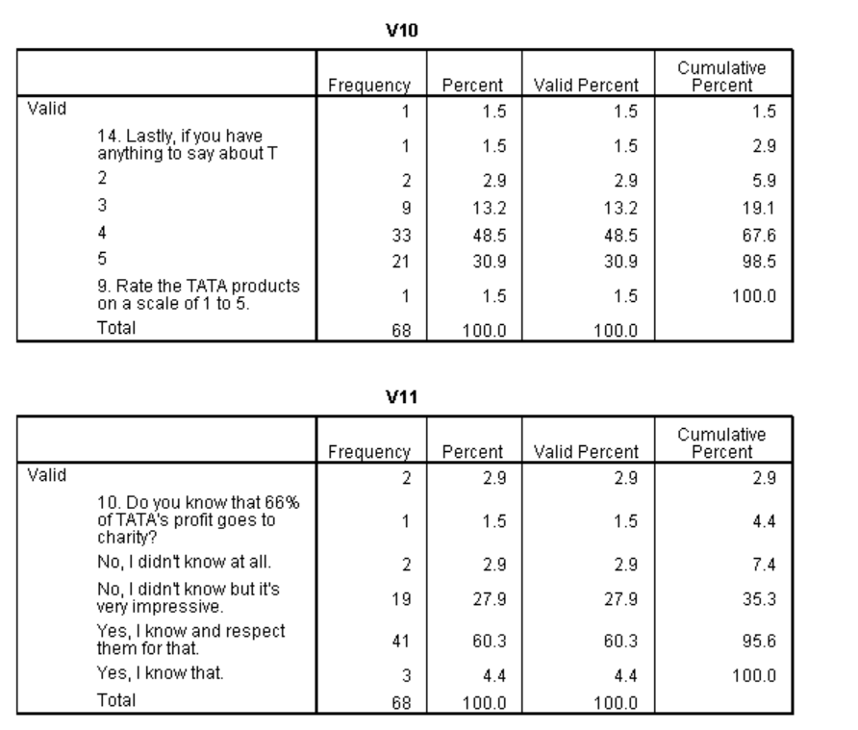 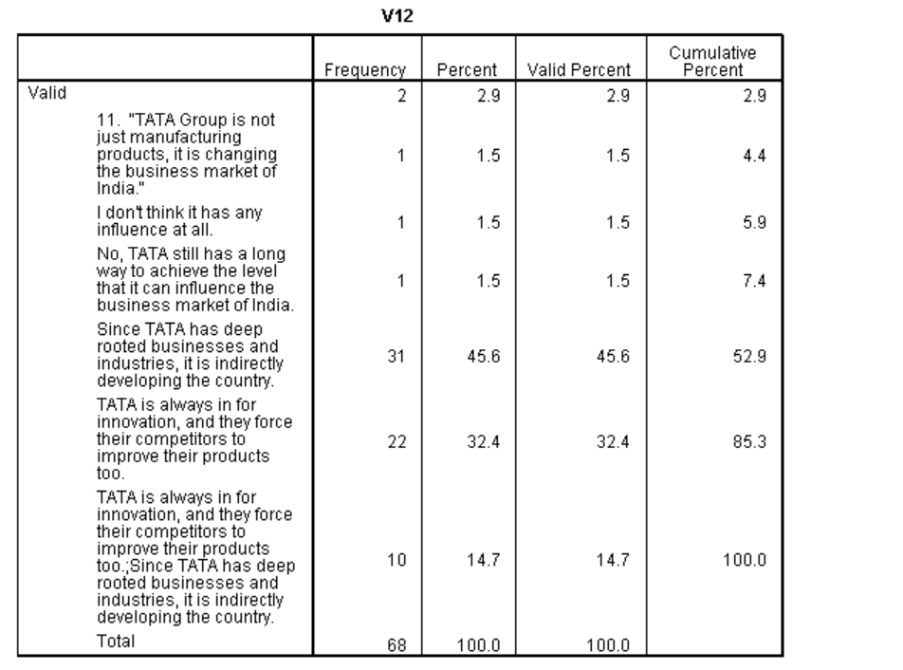 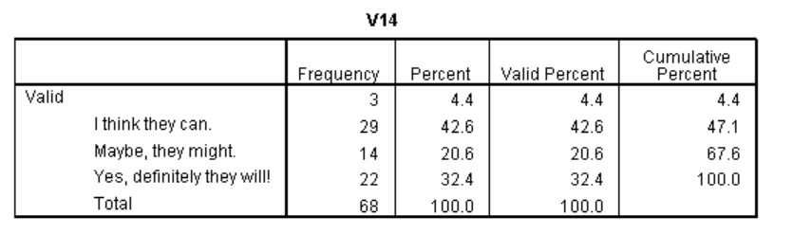 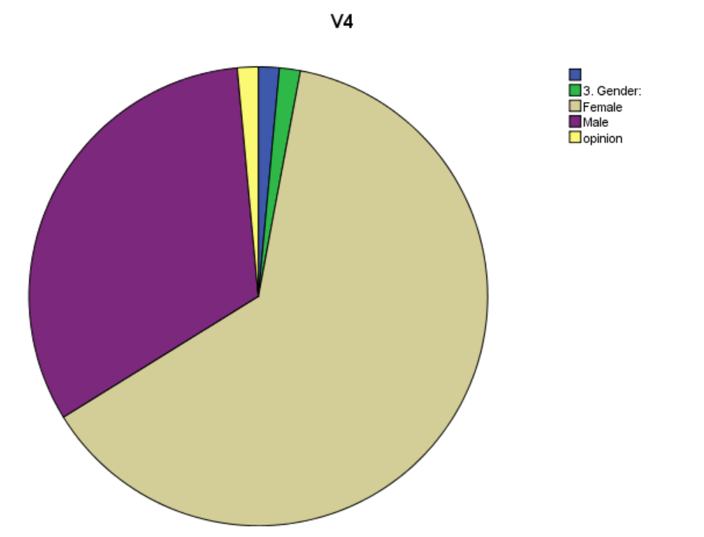 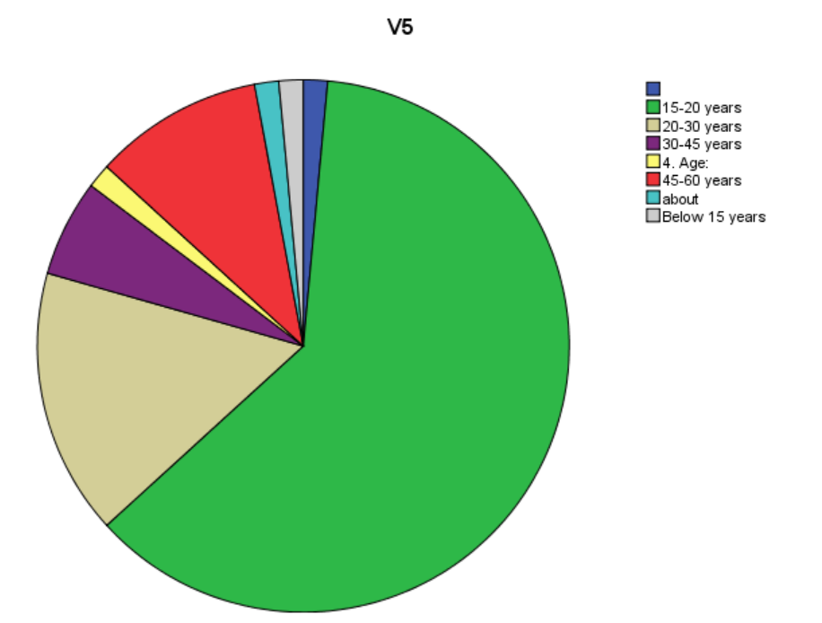 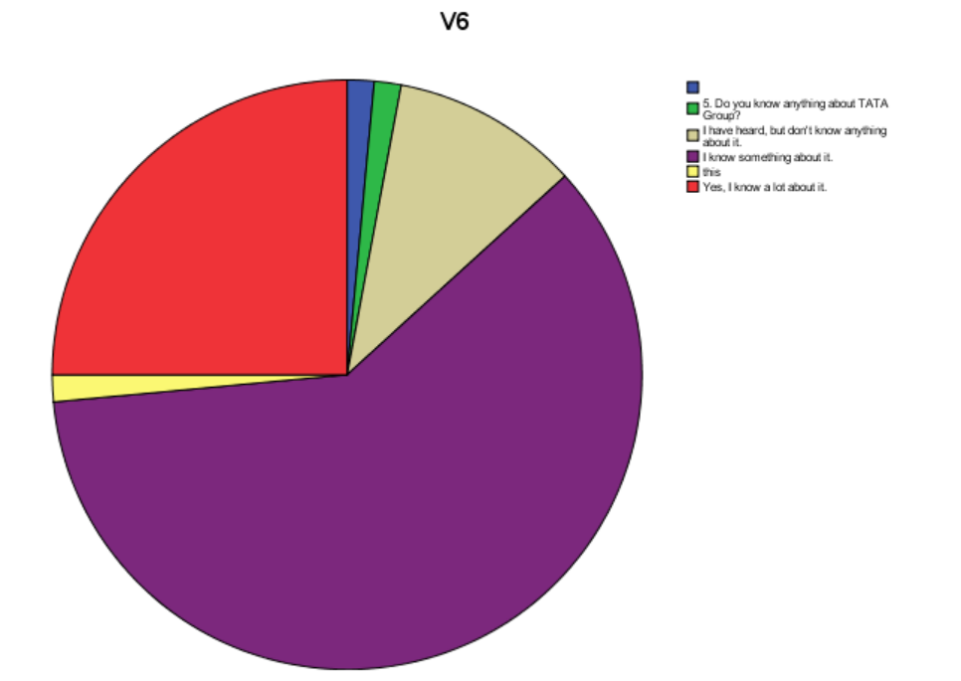 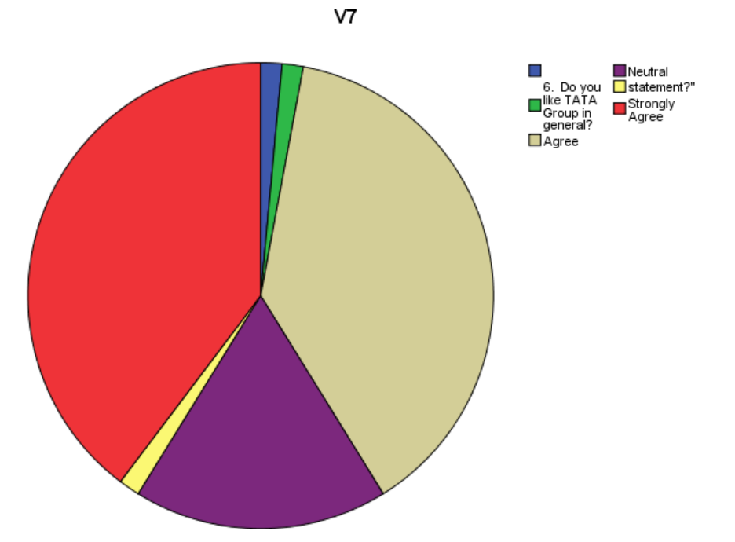 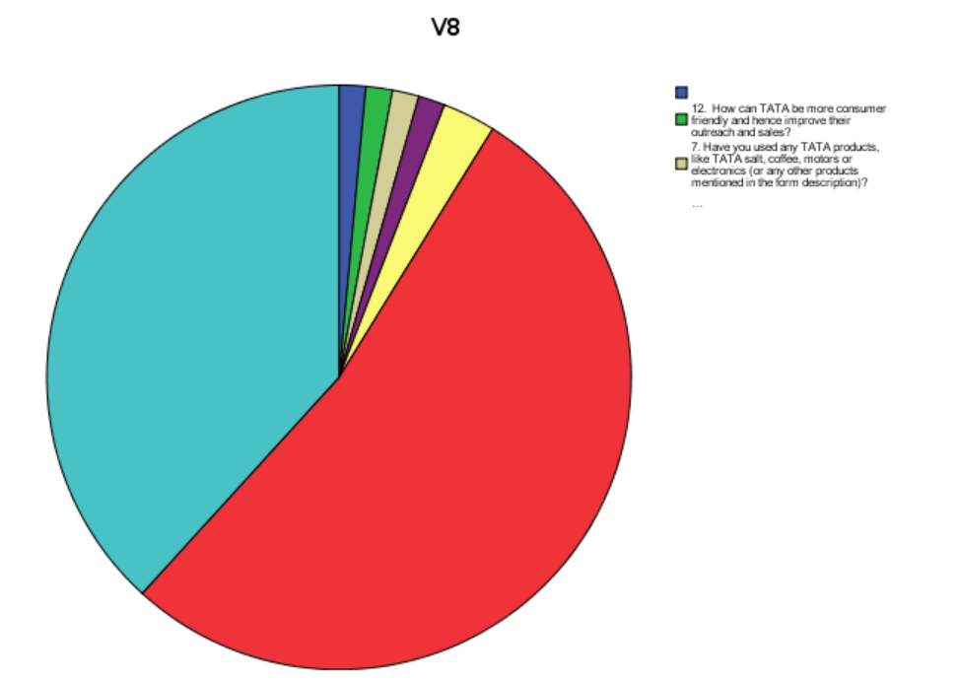 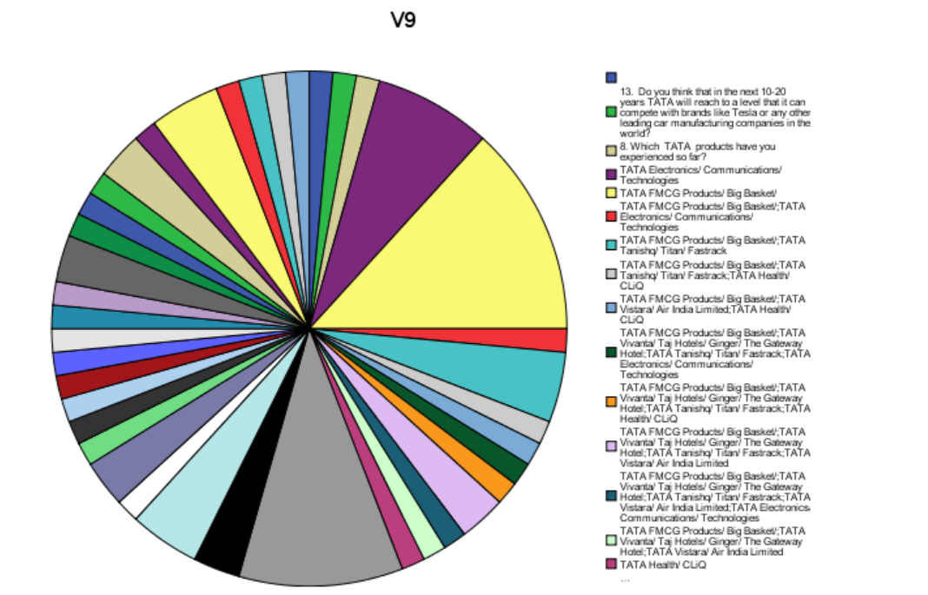 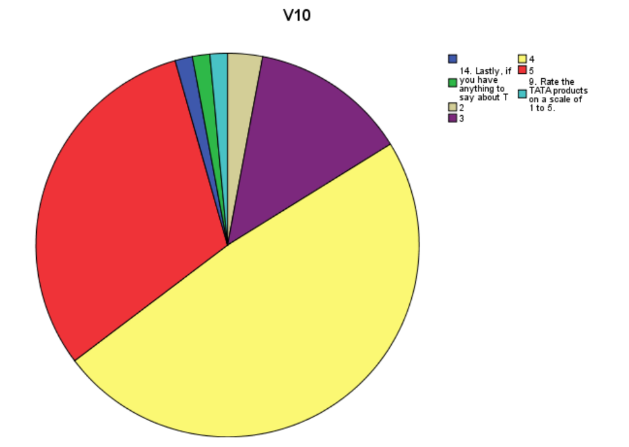 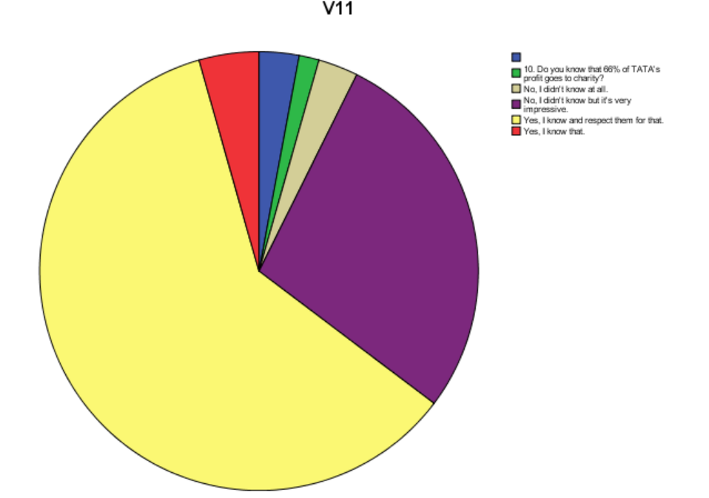 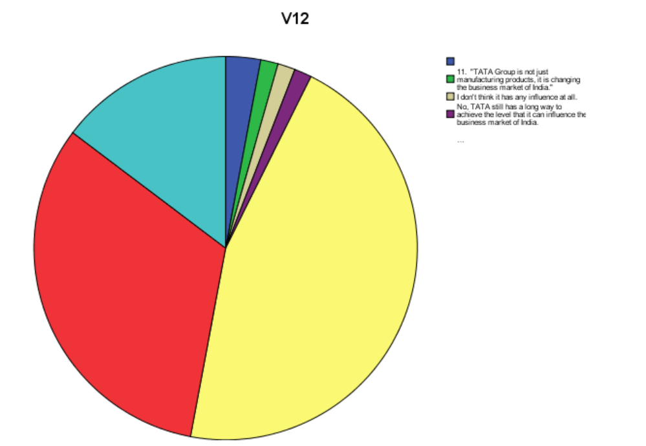 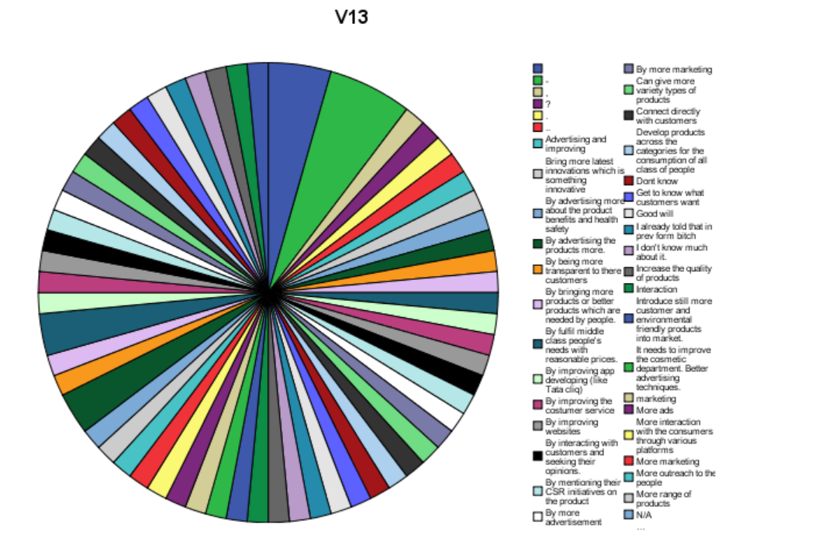 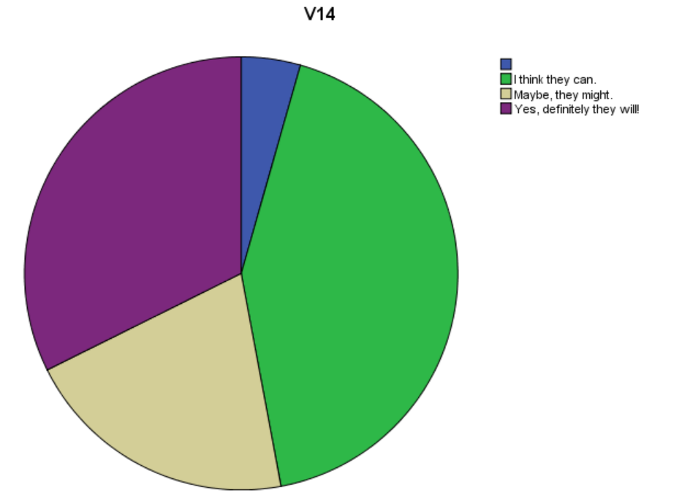

**5) Conclusion and implications**

**Reference (APA reference should be given)**

**Appendix-1 questionnaire to be attached**